**4. Implementation**

**4.1 User Interface**

Home page of the website:

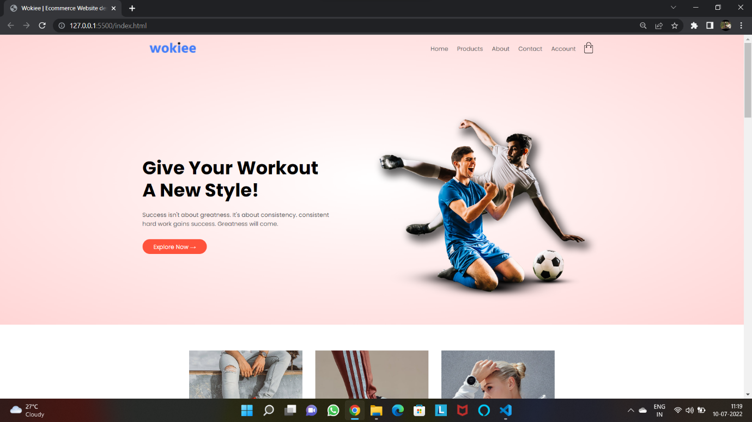

Fig. 4.1 Home Page Header

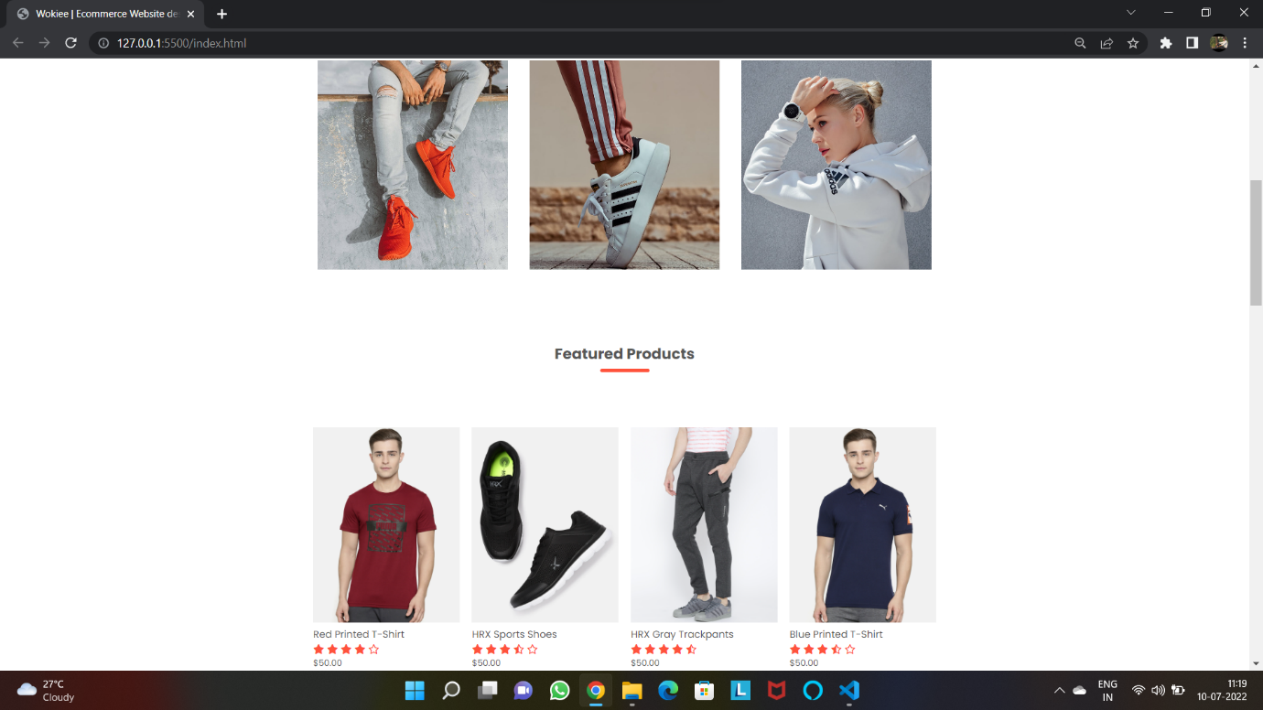

Fig. 4.2 Home Page

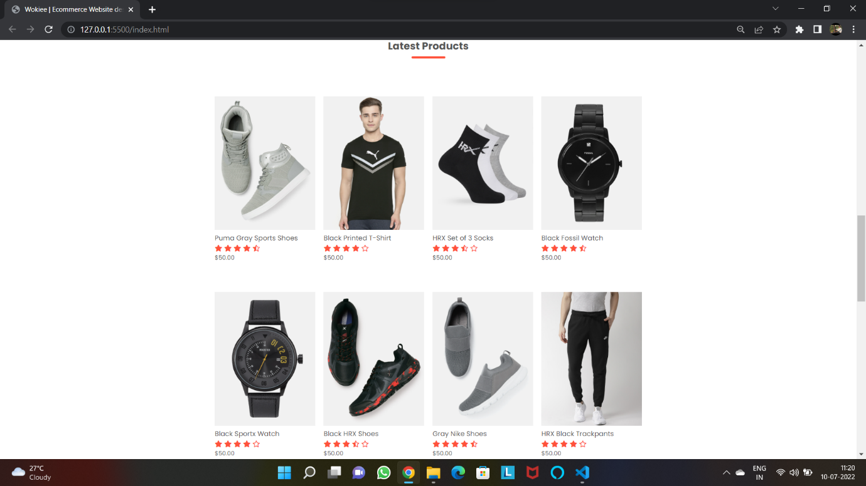

Fig. 4.3 Home Page

Exclusive Product of Home Page:

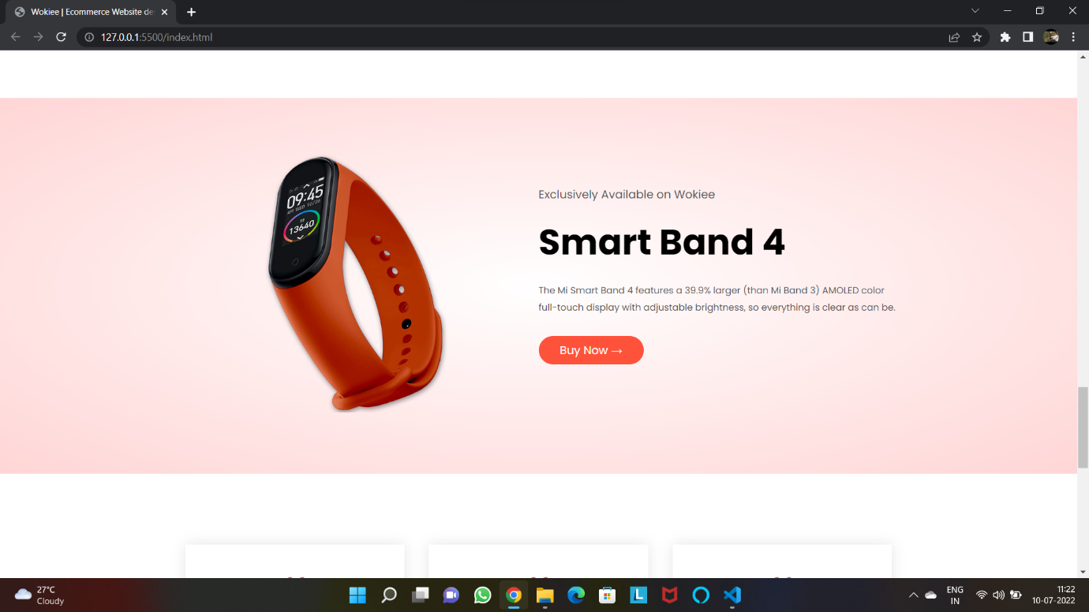

Fig. 4.4 Home Page Exclusive Product

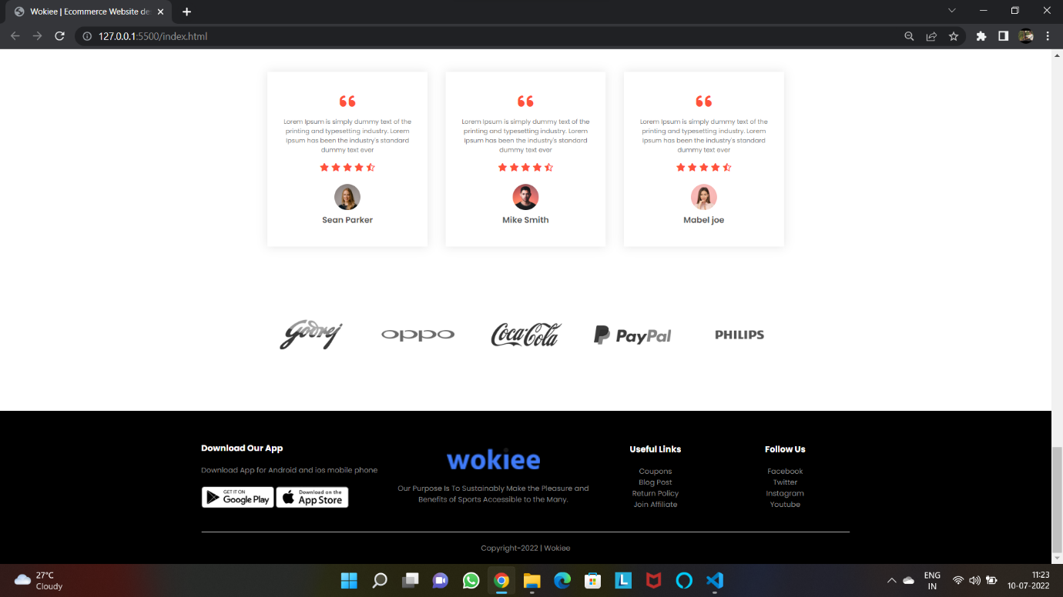

Fig. 4.5 Home Page Footer

All Products Page:

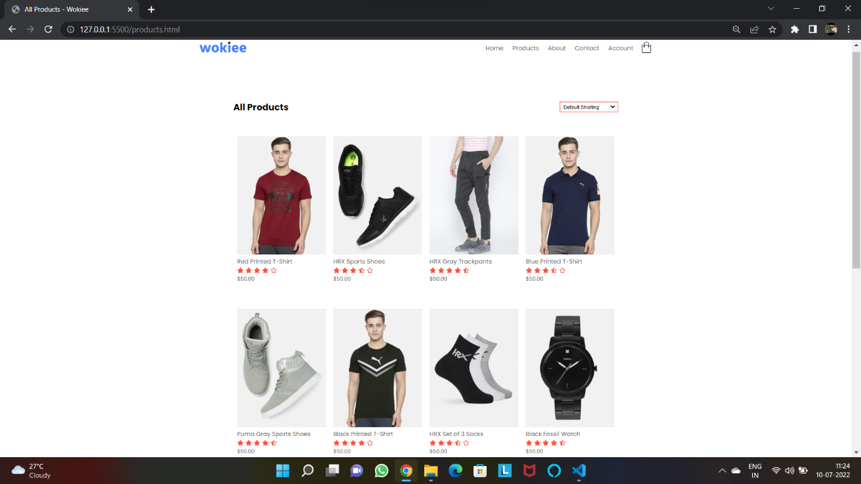

Fig. 4.6 Products Page

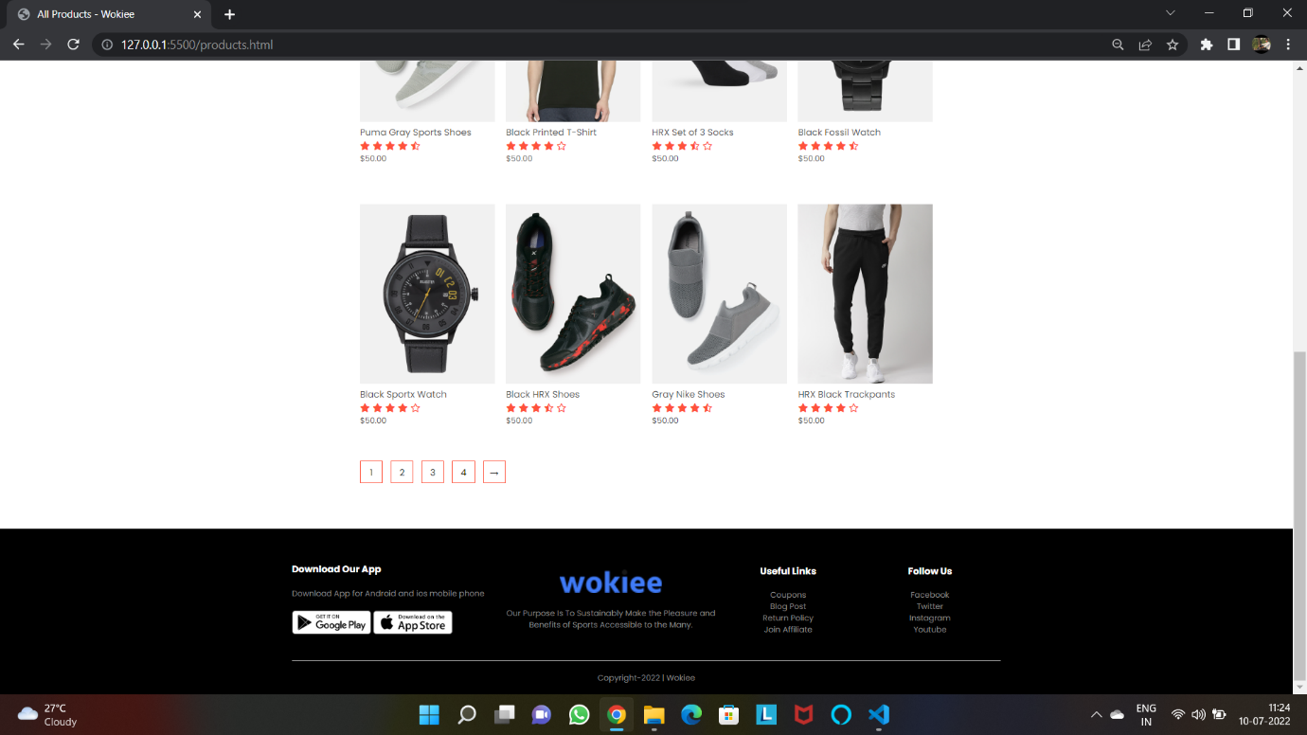

Fig. 4.7 Products Page

Product Details Page:

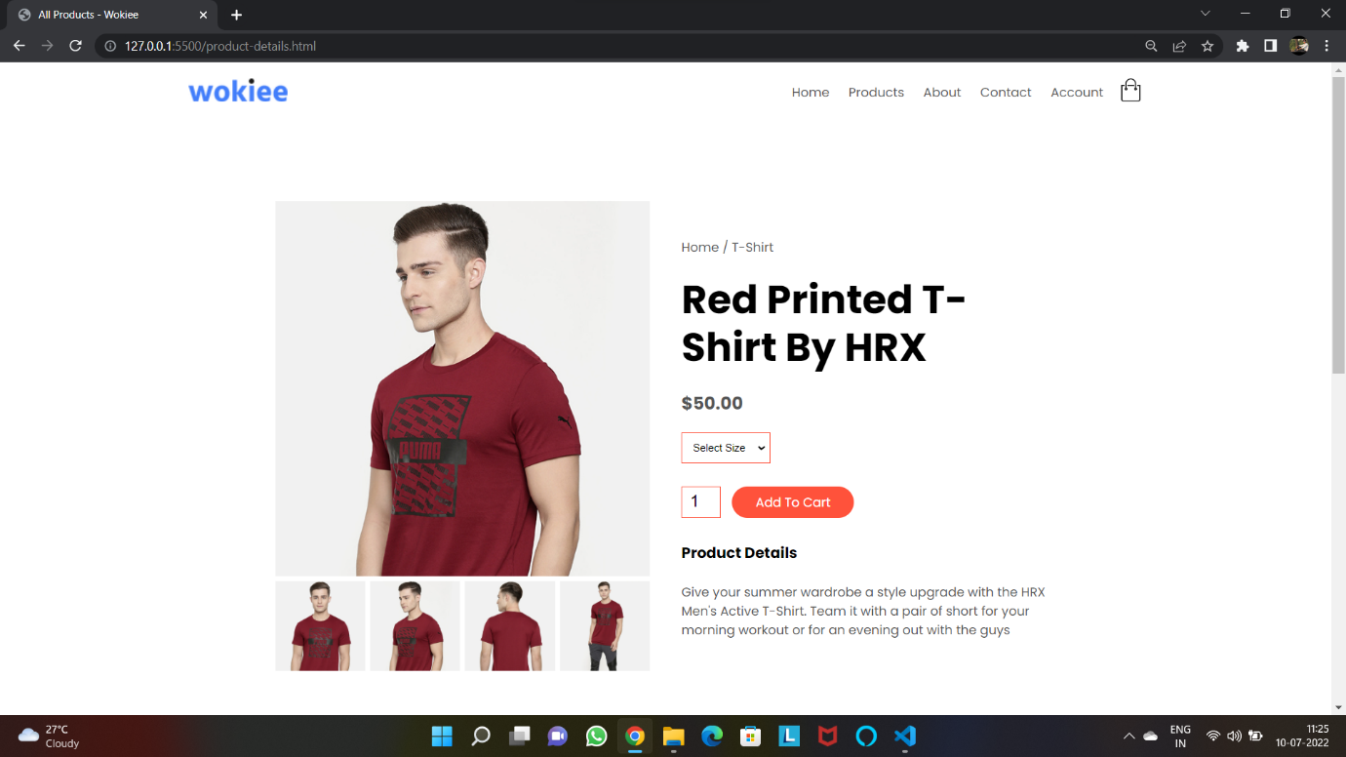

Fig. 4.8 Product Details Page

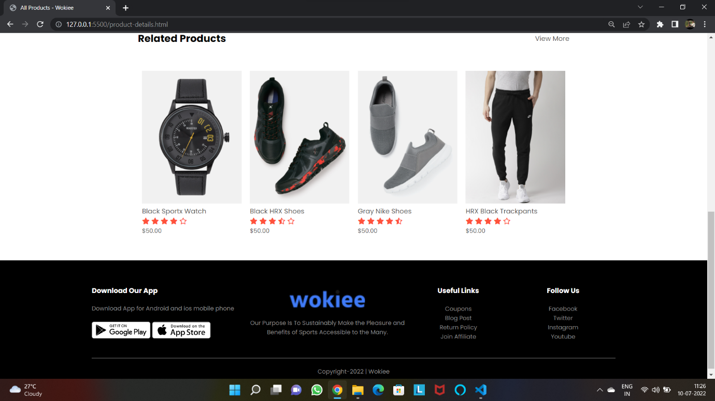

Fig. 4.9 Product Details Page

Account Page:

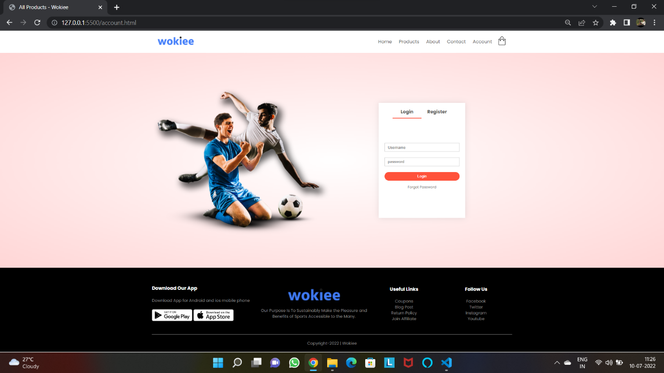

Fig. 4.10 Account Page

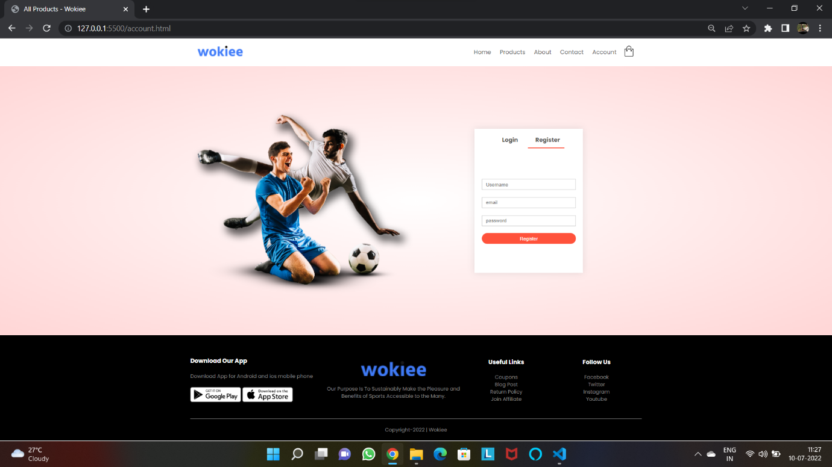

Fig. 4.11 Account Page

Cart Page:

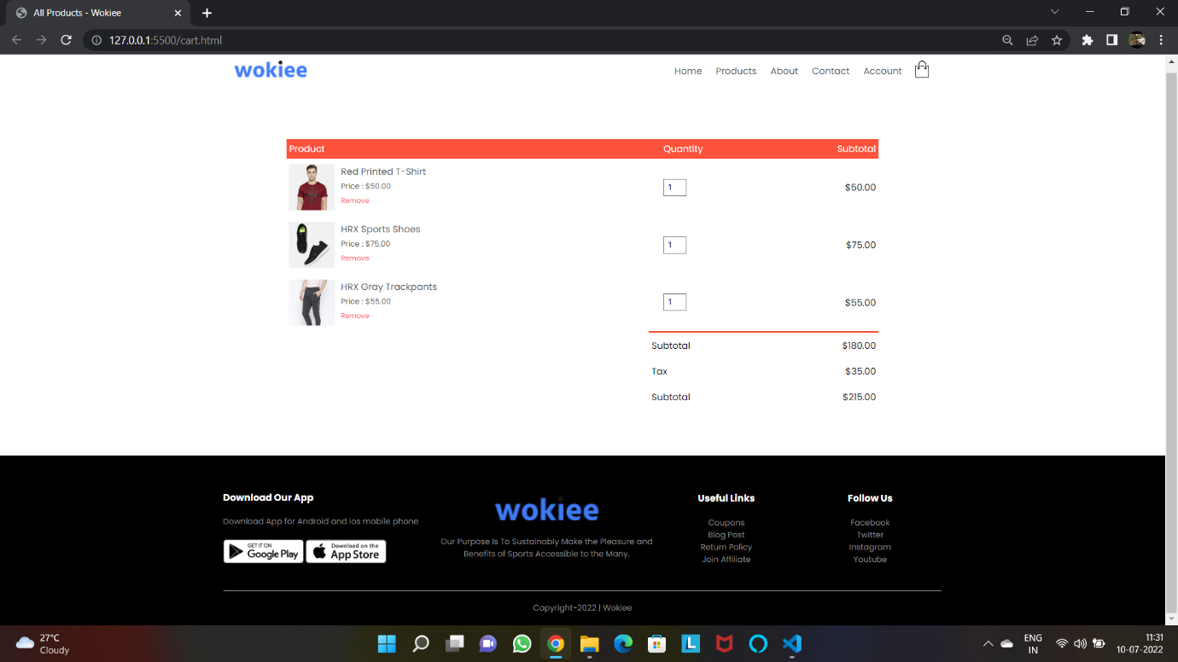

Fig. 4.12 Cart Page